**1.** Let *f*(*x*)= 7 – 2*x* and *g*(*x*)= *x* + 3.

(a) Find (*g* ° *f*)(*x*).

(b) Write down *g*–1(*x*).

(c) Find (*f* ° *g*–1)(5).

**2.** Consider *f*(*x*)= 2*kx*2 – 4*kx* + 1, for *k* ≠ 0. The equation *f*(*x*)= 0 has two equal roots.

(a) Find the value of *k*.

(b) The line *y* = *p* intersects the graph of *f*. Find all possible values of *p*.

**3.** Let *f*(*x*)= 3 ln *x* and *g*(*x*) = ln 5*x*3.

(a) Express *g*(*x*) in the form *f*(*x*)+ ln *a*, where *a* +.



(b) The graph of *g* is a transformation of the graph of *f*. Give a full geometric description of this transformation

**4.** The following diagram shows part of the graph of a quadratic function *f*.

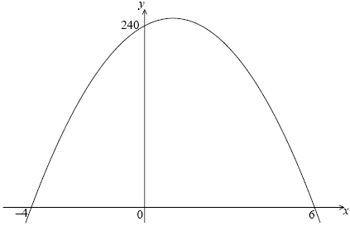

The *x*-intercepts are at (–4, 0) and (6, 0) and the *y*-intercept is at (0, 240).

(a) Write down *f*(*x*) in the form *f*(*x*) = –10(*x* – *p*)(*x* – *q*).

(b) Find another expression for *f*(*x*)in the form *f*(*x*)= –10(*x* – *h*)2 + *k*.

(c) Show that *f*(*x*) can also be written in the form *f*(*x*)= 240 + 20*x* – 10*x*2.

A particle moves along a straight line so that its velocity, *v* m s–1, at time *t* seconds is given by  
*v* = 240 + 20*t* – 10*t*2, for 0 ≤ *t* ≤ 6.

(d) (i) Find the value of *t* when the speed of the particle is greatest.

(ii) Find the acceleration of the particle when its speed is zero.

**5.** Let *f*(*x*) = 8*x* – 2*x*2. Part of the graph of *f* is shown below.

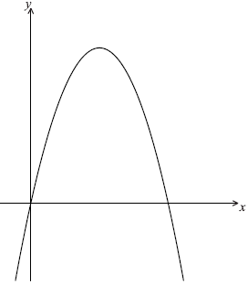

(a) Find the *x*-intercepts of the graph.

(b) (i) Write down the equation of the axis of symmetry.

(ii) Find the *y*-coordinate of the vertex.

**6.** Let *f*(*x*) = log3, for *x* > 0.



(a) Show that *f*–1(*x*) = 32*x*.

(b) Write down the range of *f*–1.

Let *g*(*x*) = log3 *x*, for *x* > 0.

(c) Find the value of (*f* –1 ° *g*)(2), giving your answer as an integer.

**7.** Let *f*(*x*) = . Part of the graph of *f* is shown below.

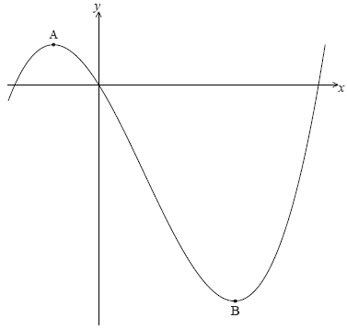

There is a maximum point at A and a minimum point at B(3, –9).

(a) Find the coordinates of A.

(b) Write down the coordinates of

(i) the image of B after reflection in the *y*-axis;

(ii) the image of B after translation by the vector ;



(iii) the image of B after reflection in the *x*-axis followed by a horizontal stretch with scale factor .



**8.** Let *f*(*x*)= *p*(*x* – *q*)(*x* – *r*). Part of the graph of *f* is shown below.

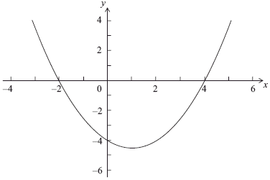

The graph passes through the points (–2, 0), (0, –4) and (4, 0).

(a) Write down the value of *q* and of *r*.

(b) Write down the **equation** of the axis of symmetry.

(c) Find the value of *p*.

**9.** Let *f*(*x*) = *x*2 + 4 and *g*(*x*) = *x* – 1.

(a) Find (*f* ° *g*)(*x*).

The vector translates the graph of (*f* ° *g*) to the graph of *h*.



(b) Find the coordinates of the vertex of the graph of *h*.

(c) Show that *h*(*x*) = *x*2 – 8*x* + 19.

(d) The line *y* = 2*x* – 6 is a tangent to the graph of *h* at the point P. Find the *x*-coordinate of P.

**10.** Let *f*(*x*) = *x*2 and *g*(*x*) = 2(*x* – 1)2.

(a) The graph of *g* can be obtained from the graph of *f* using two transformations.  
Give a full geometric description of each of the two transformations.

(b) The graph of *g* is translated by the vector to give the graph of *h*.  
The point (–1, 1) on the graph of *f* is translated to the point P on the graph of *h*.  
Find the coordinates of P.



**11.** Let *f*(*x*) = e*x+*3.

(a) (i) Show that *f*–1(*x*) = ln *x* – 3.

(ii) Write down the domain of *f*–1.

(b) Solve the equation *f*–1(*x*) = .



**12.** Let *f*(*x*) = *x*2 and *g*(*x*) = 2*x* – 3.

(a) Find *g*–1(*x*).

(b) Find (*f* ° *g*)(4).

**13.** Let *f*(*x*) = 2*x*3 + 3 and *g*(*x*) = e3*x* – 2.

(a) (i) Find *g*(0).

(ii) Find (*f* ° *g*)(0).

(b) Find *f*–1(*x*).

**14.** The diagram below shows the graph of a function *f*(*x*), for –2 ≤ *x* ≤ 4.

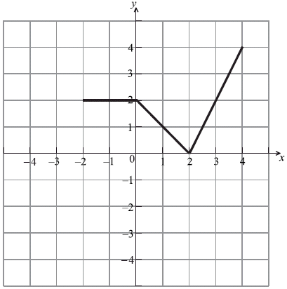

(a) Let *h*(*x*) = *f*(–*x*). Sketch the graph of *h* on the same grid.

(b) Let *g*(*x*) = *f*(*x* – 1). The point A(3, 2) on the graph of *f* is transformed to the point P on the graph of *g*. Find the coordinates of P.



**15.** Let *f*(*x*) = *k* log2 *x*.

(a) Given that *f*–1(1) = 8, find the value of *k*.

(b) Find *f*–1.



**16.** Let *f* (*x*) = ln (*x* + 5) + ln 2, for *x*  –5.

(a) Find *f* −1(*x*).

Let *g* (*x*) = e*x*.

(b) Find (*g* ◦ *f*) (*x*), giving your answer in the form *ax* + *b*, where *a*, *b*, .



**17.** Let *f* (*x*) = 3(*x* + 1)2 – 12.

(a) Show that *f* (*x*) = 3*x*2 + 6*x* – 9.

(b) For the graph of *f*

(i) write down the coordinates of the vertex;

(ii) write down the **equation** of the axis of symmetry;

(iii) write down the *y*-intercept;

(iv) find both *x*-intercepts.

(c) **Hence** sketch the graph of *f*.

(d) Let *g* (*x*) = *x*2. The graph of *f* may be obtained from the graph of *g* by the two transformations:

a stretch of scale factor *t* in the *y*-direction

followed by

a translation of



Find and the value of *t*.



**18.** The following diagram shows part of the graph of *f*, where *f* (*x*) = *x*2 − *x* − 2.

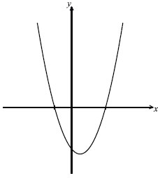

(a) Find both *x*-intercepts.

(b) Find the *x*-coordinate of the vertex.

**19.** Part of the graph of a function *f* is shown in the diagram below.



(a) On the same diagram sketch the graph of *y* = − *f* (*x*).

(b) Let *g* (*x*) = *f* (*x* + 3).

(i) Find *g* (−3).

(ii) Describe **fully** the transformation that maps the graph of *f* to the graph of *g*.

**20.** Let *f* be the function given by *f*(*x*) = e0.5*x*, 0 ≤ *x* ≤ 3.5. The diagram shows the graph of *f.*

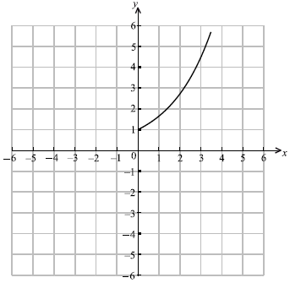

(a) On the same diagram, sketch the graph of *f*–1.

(b) Write down the range of *f*–1.

(c) Find *f*–1(*x*).

**21.** Consider *f*(*x*) = .



(a) Find

(i) *f*(11);

(ii) *f*(86);

(iii) *f*(5).

(b) Find the values of *x* for which *f* is undefined.

(c) Let g(*x*) = *x*2. Find (*g* ° *f*)(*x*).

**22.** The quadratic function *f* is defined by *f*(*x*) = 3*x*2 – 12*x* + 11.

(a) Write *f* in the form *f*(*x*) = 3(*x* – *h*)2 – *k*.

(b) The graph of *f* is translated 3 units in the positive *x*-direction and 5 units in the positive  
*y*-direction. Find the function *g* for the translated graph, giving your answer in the form  
*g*(*x*) = 3(*x* – *p*)2 + *q*.

**23.** Let *f* (*x*) = 2*x*2 – 12*x* + 5.

(a) Express *f*(*x*) in the form *f*(*x*) = 2(*x* – *h*)2 – *k*.

(b) Write down the vertex of the graph of *f*.

(c) Write down the equation of the axis of symmetry of the graph of *f*.

(d) Find the *y*-intercept of the graph of *f*.

(e) The *x*-intercepts of *f* can be written as , where *p*, *q*, *r* .  
Find the value of *p*, of *q*, and of *r*.



**24.** Let *f*(*x*) = , *x* ≠ 0.



(a) Sketch the graph of *f*.

The graph of *f* is transformed to the graph of *g* by a translation of .



(b) Find an expression for *g*(*x*).

(c) (i) Find the intercepts of *g*.

(ii) Write down the equations of the asymptotes of *g*.

(iii) Sketch the graph of *g*.

**25.** The functions *f* (*x*) and *g* (*x*) are defined by *f* (*x*) = e*x* and *g* (*x*) = ln (1+ 2*x*).

(a) Write down *f* −1(*x*).

(b) (i) Find ( *f* ◦ *g*) (*x*).

(ii) Find ( *f* ◦ *g*)−1 (*x*).

**26.** The graph of the function *y* = *f* (*x*), 0  *x*  4, is shown below.

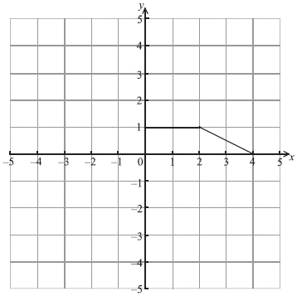

(a) Write down the value of

(i) *f* ′ (1);

(ii) *f* ′ (3).

(b) On the same diagram, draw the graph of *y* = 3 *f* (−*x*).

(c) On the same diagram below, draw the graph of *y* = *f* (2*x*).

**27.** Let *f* (*x*) = , *x*  − 4 and *g* (*x*) = *x*2, *x*  .



(a) Find (*g* ◦ *f* ) (3).

(b) Find *f* −1(*x*).

(c) Write down the domain of *f* −1.

**28.** Consider two different quadratic functions of the form *f* (*x*) = 4*x*2 − *qx* + 25. The graph of each function has its vertex on the *x*-axis.

(a) Find both values of *q*.

(b) For the greater value of *q*, solve *f* (*x*) = 0.

(c) Find the coordinates of the point of intersection of the two graphs.

**29.** The graph of a function *f* is shown in the diagram below. The point A (–1, 1) is on the graph, and *y* = −1 is a horizontal asymptote.

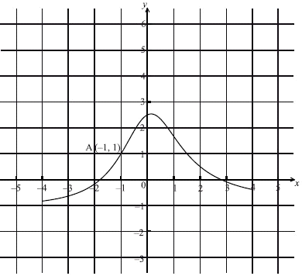

(a) Let *g* (*x*) = *f* (*x* −1) + 2. On the diagram, sketch the graph of *g*.

(b) Write down the equation of the horizontal asymptote of *g*.

(c) Let A′ be the point on the graph of *g* corresponding to point A. Write down the coordinates of A′.

**30.** The following diagram shows part of the graph of *f* (*x*).

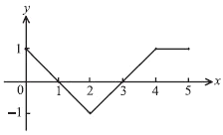

Consider the five graphs in the diagrams labelled A, B, C, D, E below.

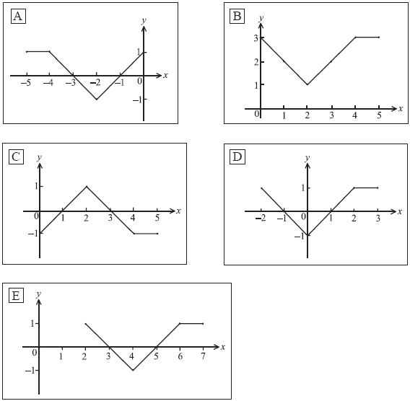

(a) Which diagram is the graph of *f* (*x* + 2) ?

(b) Which diagram is the graph of – *f* (*x*) ?

(c) Which diagram is the graph of *f* (–*x*)

**31.** Let *f* (*x*) = *x*3 − 4 and *g* (*x*) = 2*x*.

(a) Find (*g* ◦ *f* ) (−2).

(b) Find *f* −1 (*x*).

**32.** Part of the graph of the function *y* = *d* (*x* −*m*)2 + *p* is given in the diagram below.

The *x*-intercepts are (1, 0) and (5, 0). The vertex is V(*m*, 2).

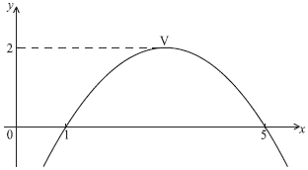

(a) Write down the value of

(i) *m*;

(ii) *p*.

(b) Find *d*.

**33.** Let *g* (*x*) = 3*x* – 2, *h* (*x*) = , *x* 4.



(a) Find an expression for (*h* ◦ *g*) (*x*). Simplify your answer.

(b) Solve the equation (*h* ◦ *g*) (*x*) = 0.

**34.** The functions *f* and *g* are defined by .



(a) Find an expression for (*f*  g) (*x*).

(b) Show that *f* –l (18) + *g*–l (18) = 22.

**35.** The function *f* is given by *f* (*x*) = e(*x*–11) –8.

(a) Find *f* –1(*x*).

(b) Write down the domain of *f* –l(*x*).

**36.** The graph of *y* = *f* (*x*) is shown in the diagram.



(a) On each of the following diagrams draw the required graph,

(i) *y* = 2 *f* (*x*);



(ii) *y* = *f* (*x* – 3).



(b) The point A (3, –1) is on the graph of *f*. The point A is the corresponding point on the graph of *y* = –*f* (*x*) + 1. Find the coordinates of A.

**37.** Part of the graph of *f* (*x*) = (*x* – *p*) (*x* – *q*) is shown below.

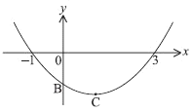

The vertex is at C. The graph crosses the *y*-axis at B.

(a) Write down the value of *p* and of *q*.

(b) Find the coordinates of C.

(c) Write down the *y*-coordinate of B.

**38.** Consider the functions *f* (*x*) = 2*x* and *g* (*x*) = , *x* 3.



(a) Calculate (*f* ◦ *g*) (4).

(b) Find *g*−1(*x*).

(c) Write down the domain of *g*−1.

**39.** The equation *x*2 – 2*kx* + 1 = 0 has two distinct real roots. Find the set of all possible values of *k*.

**40.** Let *f* (*x*) = 2*x* + 1 and *g* (*x*) = 3*x*2 – 4.

Find

(a) *f* –1(*x*);

(b) (*g*  *f* ) (–2);

(c) ( *f*  *g*) (*x*).

**41.** Let *f* (*x*) = e–*x*, and *g* (*x*) = , *x* ** –1. Find



(a) *f* –1 (*x*);

(b) (*g* ° *f* ) (*x*).

**42.** The equation *kx*2 + 3*x* + 1 = 0 has exactly one solution. Find the value of *k*.

**43.** The function *f* is given by *f* (*x*) = *x*2 – 6*x* + 13, for *x*  3.

(a) Write *f* (*x*) in the form (*x* *–* *a*)2 + *b.*

(b) Find the inverse function *f* –1.

(c) State the domain of *f* –1.

**44.** The diagram shows part of the graph of *y* = *a* (*x* – *h*)2 + *k*. The graph has its vertex at P, and passes through the point A with coordinates (1, 0).



(a) Write down the value of

(i) *h*;

(ii) *k*.

(b) Calculate the value of *a*.

**45.** Consider the function *f* (*x*) = 2*x*2 – 8*x* + 5.

(a) Express *f* (*x*) in the form *a* (*x* – *p*)2 + *q*, where *a*, *p*, *q*  .



(b) Find the minimum value of *f* (*x*).

**46.** Consider the functions *f* : *x* 4(*x* – 1) and *g* : *x .*



(a) Find *g*–1.

(b) Solve the equation ( *f* ° *g*–1) (*x*) = 4.

**47.** The sketch shows part of the graph of *y* = *f* (*x*) which passes through the points A(–1, 3), B(0, 2), C(l, 0), D(2, 1) and E(3, 5).



A second function is defined by *g* (*x*) = 2*f* (*x* – 1).

(a) Calculate *g* (0), *g* (1), *g* (2) and *g* (3).

(b) On the same axes, sketch the graph of the function *g* (*x*).

**48.** The diagram shows part of the graph with equation *y = x*2 *+ px + q.* The graph cuts the *x*-axis at –2 and 3.



Find the value of

(a) *p*;

(b) *q*.

**49.** The following diagram shows the graph of *y = f* (*x*). It has minimum and maximum points at   
(0, 0) and ().



(a) On the same diagram, draw the graph of .



(b) What are the coordinates of the minimum and maximum points of?



**50.** The diagram shows parts of the graphs of *y* = *x*2 and *y* = 5 – 3(*x* – 4)2.



The graph of *y = x*2 may be transformed into the graph of *y* = 5 – 3(*x* – 4)2 by these transformations.

A reflection in the line *y* = 0 **followed by**a vertical stretch with scale factor *k* **followed by**a horizontal translation of *p* units **followed by**a vertical translation of *q* units.

Write down the value of

(a) *k*;

(b) *p*;

(c) *q.*

**51.** Given that *f* (*x*) = 2e3*x*, find the inverse function *f* –1(*x*).

**52.** The diagram shows the graph of *y = f* (*x*), with the *x*-axis as an asymptote.



(a) On the same axes, draw the graph of *y =f* (*x* + 2) – 3, indicating the coordinates of the images of the points A and B.

(b) Write down the equation of the asymptote to the graph of *y = f* (*x* + 2) – 3.

**53.** Two functions *f*, *g* are defined as follows:

*f* : *x* 3*x* + 5  
*g* : *x*  2(1 – *x*)

Find

(a) *f* –1(2);

(b)(*g* *f* )(–4).



**54.** The quadratic equation 4*x2 +* 4*kx +* 9 *=* 0, *k >* 0 has exactly one solution for *x.*Find the value of *k.*

**55.** The diagram shows three graphs.



*A* is part of the graph of *y = x.*

*B* is part of the graph of *y* = 2*x*.

*C* is the reflection of graph *B* in line *A.*

Write down

(a) the equation of *C* in the form *y =f* (*x*);

(b) the coordinates of the point where *C* cuts the *x*-axis.

**56.** The diagrams show how the graph of *y = x*2is transformed to the graph of *y = f* (*x*)in three steps.

For each diagram give the equation of the curve.



**57.** The diagram shows the graph of the function *y = ax*2 + *bx* + *c*.



Complete the table below to show whether each expression is positive, negative or zero.

|  |  |  |  |
| --- | --- | --- | --- |
| Expression | positive | negative | zero |
| *a* |  |  |  |
| *c* |  |  |  |
| *b2* – 4*ac* |  |  |  |
| *b* |  |  |  |

**58.** (a) Factorize *x*2 – 3*x* – 10.

(b) Solve the equation *x*2 – 3*x* – 10 = 0.

**59.** The diagram represents the graph of the function

*f* : *x* (*x* – *p*)(*x* – *q*).



(a) Write down the values of *p* and *q*.

(b) The function has a minimum value at the point *C*. Find the *x*-coordinate of *C*.

**60.** The diagram shows the parabola *y* = (7 – *x*)(l + *x*). The points *A* and *C* are the *x*-intercepts and the point *B* is the maximum point.



Find the coordinates of *A*, *B* and *C*.

**61.** The function *f* is given by *f* (*x*) = Find the domain of the function.



**62.** A population of bacteria is growing at the rate of 2.3% per minute. How long will it take for the size of the population to double? Give your answer to the nearest minute.

**63.** Let *f* (*x*) = , and *g* (*x*) = 2*x*. Solve the equation



(*f* –1 *g*)(*x*) = 0.25.

