Functions Date: ______________
Leading Question: How do we use logarithms to solve equations?

Logarithmic and Exponential Equations
We saw in a previous lesson that for certain exponential equations there is a need to make use of logs in order to solve. We will investigate this a bit further:

Examples
Solve each of the following exponential equations:
a) $2^{2x+3}=32$ b) $4^{2x}=8^{x+2}$

c) $3^{x}=15$ d) $5^{3x-2}=23$

e) $2^{2x}-9=0$ f) $3^{2x}-3^{x}=0$

g) $2^{2x}-6∙2^{x}+5=0$

Examples
Solve each of the following logarithmic equations:

a) $\log_{2}{x}=5$ b) $\log_{3}{81}=x$

c) $\log_{x}{16}=4$ d) $\log_{2}{x}+\log_{2}{3}=7$

e) $\log_{3}{x}-\log_{3}{(x-1)}=5$ f) $\log_{5}{x+\log_{5}\left(x-1\right)=\log_{5}{12}}$

g) ${\left(\log_{2}{x}\right)}^{2}+\log_{2}{x}-2=0$ h) $\log_{3}\left(3^{x+1}-9\right)=x$

Independent Practice
1
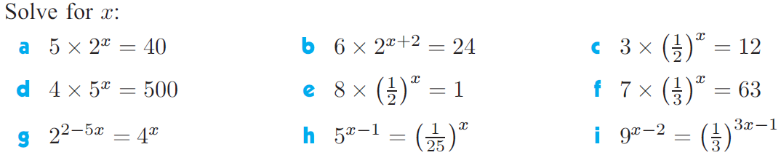
2
3
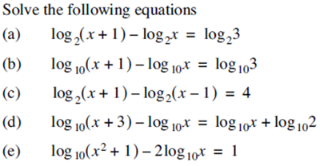
4
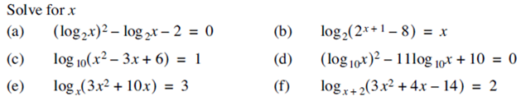

Answers
1
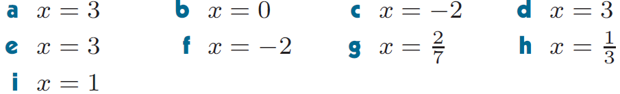
2

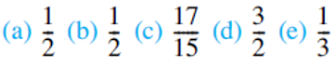
3
4

