**1.** The following diagram shows triangle ABC.

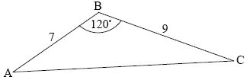

***diagram not to scale***

AB = 7 cm, BC = 9 cm and = 120°.



(a) Find AC.

(3)

(b) Find .



(3)

(Total 6 marks)

**2.** The following diagram shows a waterwheel with a bucket. The wheel rotates at a constant rate in an anticlockwise (counterclockwise) direction.

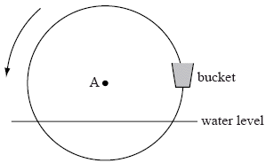

***diagram not to scale***

The diameter of the wheel is 8 metres. The centre of the wheel, A, is 2 metres above the water level. After *t* seconds, the height of the bucket above the water level is given by *h* = *a* sin *bt* + 2.

(a) Show that *a* = 4.

(2)

The wheel turns at a rate of one rotation every 30 seconds.

(b) Show that *b* = .



(2)

In the first rotation, there are two values of *t* when the bucket is **descending** at a rate of  
0.5 m s–1.

(c) Find these values of *t*.

(6)

(d) Determine whether the bucket is underwater at the second value of *t*.

(4)

(Total 14 marks)

**3.** There is a vertical tower TA of height 36 m at the base A of a hill. A straight path goes up the hill from A to a point U. This information is represented by the following diagram.

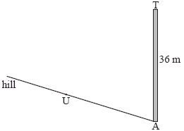

The path makes a 4° angle with the horizontal.  
The point U on the path is 25 m away from the base of the tower.  
The top of the tower is fixed to U by a wire of length *x* m.

(a) Complete the diagram, showing clearly all the information above.

(3)

(b) Find *x*.

(4)

(Total 7 marks)

**4.** The diagram below shows a plan for a window in the shape of a trapezium.

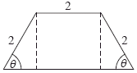

Three sides of the window are 2 m long. The angle between the sloping sides of the window and the base is *θ*, where 0 < *θ* < .



(a) Show that the area of the window is given by *y* = 4 sin *θ* + 2 sin 2*θ*.

(5)

(b) Zoe wants a window to have an area of 5 m2. Find the two possible values of *θ*.

(4)

(c) John wants two windows which have the same area *A* but different values of *θ*.

Find all possible values for *A*.

(7)

(Total 16 marks)

**5.** The graph of *y* = *p* cos *qx* + *r*, for –5 ≤ *x* ≤ 14, is shown below.

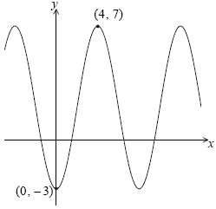

There is a minimum point at (0, –3) and a maximum point at (4, 7).

(a) Find the value of

(i) *p*;

(ii) *q*;

(iii) *r*.

(6)

(b) The equation *y* = *k* has exactly **two** solutions. Write down the value of *k*.

(1)

(Total 7 marks)

**6.** The diagram below shows a quadrilateral ABCD with obtuse angles and .

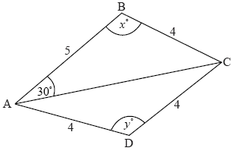

***diagram not to scale***

AB = 5 cm, BC = 4 cm, CD = 4 cm, AD = 4 cm, = 30°, = *x*°, = *y*°.



(a) Use the cosine rule to show that AC = .



(1)

(b) Use the sine rule in triangle ABC to find another expression for AC.

(2)

(c) (i) Hence, find *x*, giving your answer to two decimal places.

(ii) Find AC.

(6)

(d) (i) Find *y*.

(ii) Hence, or otherwise, find the area of triangle ACD.

(5)

(Total 14 marks)

**7.** The diagram below shows a circle with centre O and radius 8 cm.

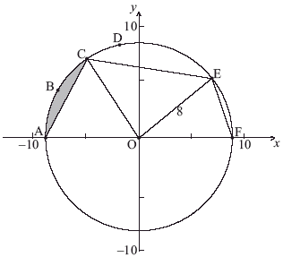

***diagram not to scale***

The points A, B, C, D, E and F are on the circle, and [AF] is a diameter. The length of arc ABC is 6 cm.

(a) Find the size of angle AOC.

(2)

(b) Hence find the area of the shaded region.

(6)

The area of sector OCDE is 45 cm2.

(c) Find the size of angle COE.

(2)

(d) Find EF.

(5)

(Total 15 marks)

**8.** The following diagram shows the triangle ABC.

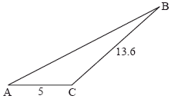

***diagram not to scale***

The angle at C is obtuse, AC = 5 cm, BC = 13.6 cm and the area is 20 cm2.

(a) Find .



(4)

(b) Find AB.

(3)

(Total 7 marks)

**9.** The following diagram represents a large Ferris wheel at an amusement park.  
The points P, Q and R represent different positions of a seat on the wheel.

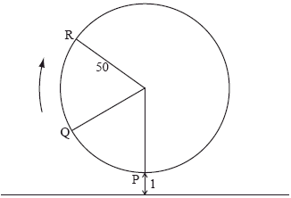

The wheel has a radius of 50 metres and rotates clockwise at a rate of one revolution every 30 minutes.

A seat starts at the lowest point P, when its height is one metre above the ground.

(a) Find the height of a seat above the ground after 15 minutes.

(2)

(b) After six minutes, the seat is at point Q. Find its height above the ground at Q.

(5)

The height of the seat above ground after t minutes can be modelled by the function  
*h*(*t*) = 50 sin (*b*(*t* – *c*)) + 51.

(c) Find the value of *b* and of *c*.

(6)

(d) Hence find the value of *t* the first time the seat is 96 m above the ground.

(3)

(Total 16 marks)

**10.** The circle shown has centre O and radius 3.9 cm.

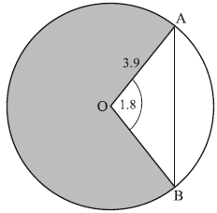

***diagram not to scale***

Points A and B lie on the circle and angle AOB is 1.8 radians.

(a) Find AB.

(3)

(b) Find the area of the shaded region.

(4)

(Total 7 marks)

**11.** Let *f*(*x*) = +1, *g*(*x*) = 4cos – 1. Let *h*(*x*) = (*g* ° *f*)(*x*).



(a) Find an expression for *h*(*x*).

(3)

(b) Write down the period of *h*.

(1)

(c) Write down the range of *h*.

(2)

(Total 6 marks)

**12.** The diagram below shows a triangle ABD with AB = 13 cm and AD = 6.5 cm.  
Let C be a point on the line BD such that BC = AC = 7 cm.

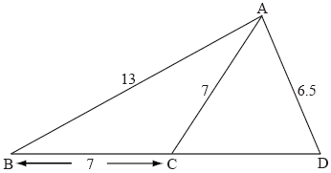

***diagram not to scale***

(a) Find the size of angle ACB.

(3)

(b) Find the size of angle CAD.

(5)

(Total 8 marks)

**13.** The following diagram shows a circle with centre O and radius 4 cm.

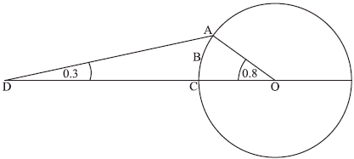

***diagram not to scale***

The points A, B and C lie on the circle. The point D is outside the circle, on (OC).  
Angle ADC = 0.3 radians and angle AOC = 0.8 radians.

(a) Find AD.

(3)

(b) Find OD.

(4)

(c) Find the area of sector OABC.

(2)

(d) Find the area of region ABCD.

(4)

(Total 13 marks)

**14.** Let *f*(*x*) = and *g*(*x*) = –0.5*x*2 + 5*x* – 8, for 0 ≤ *x* ≤ 9.



(a) On the same diagram, sketch the graphs of *f* and *g*.

(3)

(b) Consider the graph of *f*. Write down

(i) the *x*-intercept that lies between *x* = 0 and *x* =3;

(ii) the period;

(iii) the amplitude.

(4)

(c) Consider the graph of *g*. Write down

(i) the two *x*-intercepts;

(ii) the equation of the axis of symmetry.

(3)

(d) Let *R* be the region enclosed by the graphs of *f* and *g*. Find the area of *R*.

(5)

(Total 15 marks)

**15.** The diagram below shows triangle PQR. The length of [PQ] is 7 cm, the length of [PR] is 10 cm, and is 75.

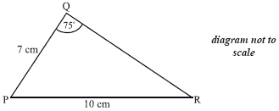

(a) Find



(3)

(b) Find the area of triangle PQR.

(3)

(Total 6 marks)

**16.** The diagram below shows a circle centre O, with radius *r*. The length of arc ABC is 3 cm and =

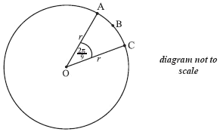

(a) Find the value of *r*.

(2)

(b) Find the perimeter of sector OABC.

(2)

(c) Find the area of sector OABC.

(2)

(Total 6 marks)

**17.** Let *f* (*x*) = 4 tan2 *x* – 4 sin *x*,



(a) On the grid below, sketch the graph of *y* = *f* (*x*).

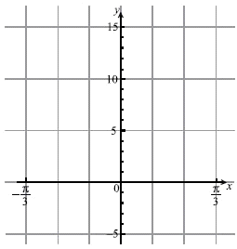

(3)

(b) Solve the equation *f* (*x*) = 1.

(3)

(Total 6 marks)

**18.** The following graph shows the depth of water, *y* metres, at a point P, during one day.

The time *t* is given in hours, from midnight to noon.

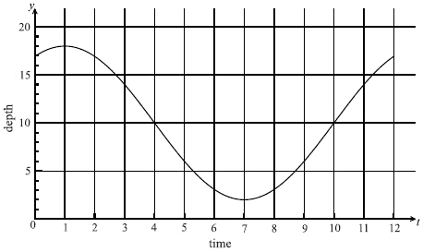

(a) Use the graph to write down an estimate of the value of *t* when

(i) the depth of water is minimum;

(ii) the depth of water is maximum;

(iii) the depth of the water is increasing most rapidly.

(3)

(b) The depth of water can be modelled by the function *y* = *A* cos (*B* (*t* – 1)) + *C*.

(i) Show that *A* = 8.

(ii) Write down the value of *C*.

(iii) Find the value of *B*.

(6)

(c) A sailor knows that he cannot sail past P when the depth of the water is less than 12 m. Calculate the values of *t* between which he cannot sail past P.

(2)

(Total 11 marks)

**19.** A ship leaves port A on a bearing of 030°. It sails a distance of 25 km to point B.  
At B, the ship changes direction to a bearing of 100°. It sails a distance of 40 km to reach point C. This information is shown in the diagram below.

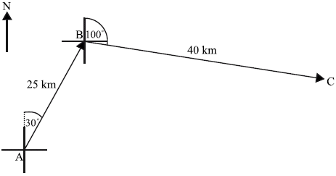

***diagram not to scale***

A second ship leaves port A and sails directly to C.

(a) Find the distance the second ship will travel.

(4)

(b) Find the bearing of the course taken by the second ship.

(3)

(Total 7 marks)

**20.** A farmer owns a triangular field ABC. One side of the triangle, [AC], is 104 m, a second side, [AB], is 65 m and the angle between these two sides is 60°.

(a) Use the cosine rule to calculate the length of the third side of the field.

(3)

(b) Given that sin 60°= , find the area of the field in the form where *p* is an integer.



(3)

Let D be a point on [BC] such that [AD] bisects the 60° angle. The farmer divides the field into two parts *A*1 and *A*2 by constructing a straight fence [AD] of length *x* metres, as shown on the diagram below.

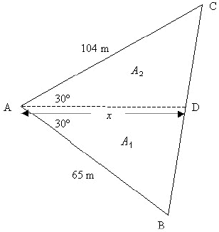

(c) (i) Show that the area of *A*1 is given by .



(ii) Find a similar expression for the area of *A*2.

(iii) **Hence**, find the value of *x* in the form , where *q* is an integer.



(7)

(d) (i) Explain why .



(ii) Use the result of part (i) and the sine rule to show that .



(5)

(Total 18 marks)

**21.** The following diagram shows the triangle AOP, where OP = 2 cm, AP = 4 cm and AO = 3 cm.



(a) Calculate , giving your answer in radians.



(3)

The following diagram shows two circles which intersect at the points A and B. The smaller circle *C*1 has centre O and radius 3 cm, the larger circle *C*2 has centre P and radius 4 cm, and OP = 2 cm. The point D lies on the circumference of *C*1 and E on the circumference of *C*2.Triangle AOP is the same as triangle AOP in the diagram above.



(b) Find , giving your answer in radians.



(2)

(c) Given that is 1.63 **radians**, calculate the area of



(i) sector PAEB;

(ii) sector OADB.

(5)

(d) The area of the quadrilateral AOBP is 5.81 cm2.

(i) Find the area of AOBE.

(ii) Hence find the area of the shaded region AEBD.

(4)

(Total 14 marks)

**22.** The following diagram shows a pentagon ABCDE, with AB = 9.2 cm, BC = 3.2 cm, BD = 7.1 cm, =110, = 52 and = 60.

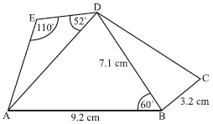

(a) Find AD.

(4)

(b) Find DE.

(4)

(c) The area of triangle BCD is 5.68 cm2. Find .



(4)

(d) Find AC.

(4)

(e) Find the area of quadrilateral ABCD.

(5)

(Total 21 marks)

**23.** (a) Consider the equation 4*x*2 + *kx* + 1 = 0. For what values of *k* does this equation have two **equal** roots?

(3)

Let *f* be the function *f* (** ) = 2 cos 2** + 4 cos ** + 3, for −360  **  360.

(b) Show that this function may be written as *f* (** ) = 4 cos2 ** + 4 cos ** + 1.

(1)

(c) Consider the equation *f* (** ) = 0, for −360  **  360.

(i) How many distinct values of cos ** satisfy this equation?

(ii) Find all values of ** which satisfy this equation.

(5)

(d) Given that *f* (** ) = *c* is satisfied by only three values of **, find the value of *c*.

(2)

(Total 11 marks)

**24.** A Ferris wheel with centre O and a radius of 15 metres is represented in the diagram below. Initially seat A is at ground level. The next seat is B, where = .

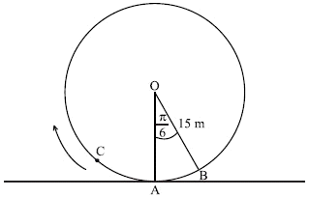

(a) Find the length of the arc AB.

(2)

(b) Find the area of the sector AOB.

(2)

(c) The wheel turns clockwise through an angle of . Find the height of A above the ground.



(3)

The height, *h* metres, of seat C above the ground after *t* minutes, can be modelled by the function

*h* (*t*) = 15 − 15 cos .



(d) (i) Find the height of seat C when *t* = .



(ii) Find the initial height of seat C.

(iii) Find the time at which seat C first reaches its highest point.

(8)

(e) Find *h*′ (*t*).

(2)

(f) For 0  *t*  ,

(i) sketch the graph of *h*′;

(ii) find the time at which the height is changing most rapidly.

(5)

(Total 22 marks)

**25.** The diagram below shows a quadrilateral ABCD. AB = 4, AD = 8, CD =12, BD = 25,  =**.

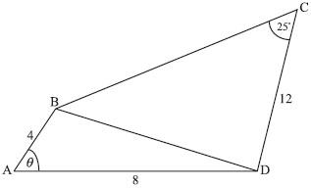

(a) Use the cosine rule to show that BD = .



(2)

Let ** = 40.

(b) (i) Find the value of sin .



(ii) Find the two possible values for the size of .



(iii) Given that is an acute angle, find the perimeter of ABCD.



(12)

(c) Find the area of triangle ABD.

(2)

(Total 16 marks)

**26.** The following diagram shows two semi-circles. The larger one has centre O and radius 4 cm. The smaller one has centre P, radius 3 cm, and passes through O. The line (OP) meets the larger semi-circle at S. The semi-circles intersect at Q.

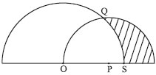

(a) (i) Explain why OPQ is an isosceles triangle.

(ii) Use the cosine rule to show that cos = .



(iii) Hence show that sin = .



(iv) Find the area of the triangle OPQ.

(7)

(b) Consider the smaller semi-circle, with centre P.

(i) Write down the size of



(ii) Calculate the area of the sector OPQ.

(3)

(c) Consider the larger semi-circle, with centre O. Calculate the area of the sector QOS.

(3)

(d) Hence calculate the area of the shaded region.

(4)

(Total 17 marks)

**27.** A farmer owns a triangular field ABC. One side of the triangle, [AC], is 104 m, a second side, [AB], is 65 m and the angle between these two sides is 60°.

(a) Use the cosine rule to calculate the length of the third side of the field.

(3)

(b) Given that sin 60° = find the area of the field in the form where *p* is an integer.



(3)

Let D be a point on [BC] such that [AD] bisects the 60° angle. The farmer divides the field into two parts *A*1 and *A*2 by constructing a straight fence [AD] of length *x* metres, as shown on the diagram below.



(c) (i) Show that the area of Al is given by .



(ii) Find a similar expression for the area of A2.

(iii) **Hence**, find the value of *x* in the form , where *q* is an integer.



(7)

(d) (i) Explain why .



(ii) Use the result of part (i) and the sine rule to show that

.



(5)

(Total 18 marks)

**28.** The diagram shows a triangular region formed by a hedge [AB], a part of a river bank [AC] and a fence [BC]. The hedge is 17 m long and is 29°. The end of the fence, point C, can be positioned anywhere along the river bank.



(a) Given that point C is 15 m from A, find the length of the fence [BC].



(3)

(b) The farmer has another, longer fence. It is possible for him to enclose two different triangular regions with this fence. He places the fence so that is 85°.



(i) Find the distance from A to C.

(ii) Find the area of the region ABC with the fence in this position.

(5)

(c) To form the second region, he moves the fencing so that point C is closer to point A.  
Find the new distance from A to C.

(4)

(d) Find the minimum length of fence [BC] needed to enclose a triangular region ABC.

(2)

(Total 14 marks)

**29.** Let *f* (*x*) = sin 2*x* + cos *x* for 0  *x*  2.



(a) (i) Find *f* (*x*).

One way of writing *f* (*x*) is –2 sin2 *x* – sin *x* + 1.

(ii) Factorize 2 sin2 *x* + sin *x* – 1.

(iii) Hence or otherwise, solve *f* (*x*) = 0.

(6)

The graph of *y* = *f* (*x*) is shown below.



There is a maximum point at A and a minimum point at B.

(b) Write down the *x*-coordinate of point A.

(1)

(c) The region bounded by the graph, the *x*-axis and the lines *x* = *a* and *x* = *b* is shaded in the diagram above.

(i) Write down an expression that represents the area of this shaded region.

(ii) Calculate the area of this shaded region.

(5)

(Total 12 marks)

**30.** The depth *y* metres of water in a harbour is given by the equation

*y* = 10 + 4 sin,



where *t* is the number of hours after midnight.

(a) Calculate the depth of the water

(i) when *t* = 2;

(ii) at 2100.

(3)

The sketch below shows the depth *y*, of water, at time *t*, during one day (24 hours).



(b) (i) Write down the maximum depth of water in the harbour.

(ii) Calculate the value of *t* when the water is first at its maximum depth during the day.

(3)

The harbour gates are closed when the depth of the water is less than seven metres. An alarm rings when the gates are opened or closed.

(c) (i) How many times does the alarm sound during the day?

(ii) Find the value of *t* when the alarm sounds first.

(iii) Use the graph to find the length of time during the day when the harbour gates are closed. Give your answer in hours, to the nearest hour.

(7)

(Total 13 marks)

**31.** Let *f* (*x*) = 1 + 3 cos (2*x*) for 0  *x*  *π*, and *x* is in radians.

(a) (i) Find *f* (*x*).

(ii) Find the values for *x* for which *f* (*x*) = 0, giving your answers in terms of .

(6)

The function *g* (*x*) is defined as *g* (*x*) = *f* (2*x*) – 1, 0  *x*  .



(b) (i) The graph of *f* may be transformed to the graph of *g* by a stretch in the *x*-direction with scale factor followed by another transformation. Describe fully this other transformation.



(ii) Find the solution to the equation *g* (*x*) = *f* (*x*)

(4)

(Total 10 marks)

**32.** The diagram shows a parallelogram OPQR in which = , =



(a) Find the vector .



(3)

(b) Use the scalar product of two vectors to show that cos = –



(4)

(c) (i) Explain why cos = –cos



(ii) Hence show that sin = .



(iii) Calculate the area of the parallelogram OPQR, giving your answer as an integer.

(7)

(Total 14 marks)

**33.** The points P, Q, R are three markers on level ground, joined by straight paths PQ, QR, PR as shown in the diagram. QR = 9 km, = 35°, = 25°.



**Diagram not to scale**



(a) Find the length PR.

(3)

(b) Tom sets out to walk from Q to P at a steady speed of 8 km h–1. At the same time, Alan sets out to jog from R to P at a steady speed of *a* km h–1. They reach P at the same time. Calculate the value of *a*.

(7)

(c) The point S is on [PQ], such that RS = 2QS, as shown in the diagram.



Find the length QS.

(6)

(Total 16 marks)

**34.** Consider the function *f* (*x*) = cos *x* + sin *x.*

(a) (i) Show that *f* (–) = 0.



(ii) Find in terms of , the smallest **positive** value of *x* which satisfies *f* (*x*) = 0.

(3)

The diagram shows the graph of *y* = e*x* (cos *x* + sin *x*), – 2  *x*  3. The graph has a maximum turning point at C(*a*, *b*) and a point of inflexion at D.



(b) Find .



(3)

(c) Find the **exact** value of *a* and of *b*.

(4)

(d) Show that at D, *y* = .



(5)

(e) Find the area of the shaded region.

(2)

(Total 17 marks)

**35.** The diagram below shows a circle, centre O, with a radius 12 cm. The chord AB subtends at an angle of 75° at the centre. The tangents to the circle at A and at B meet at P.



(a) Using the cosine rule, show that the length of AB is 12.



(2)

(b) Find the length of BP.

(3)

(c) Hence find

(i) the area of triangle OBP;

(ii) the area of triangle ABP.

(4)

(d) Find the area of **sector** OAB.

(2)

(e) Find the area of the shaded region.

(2)

(Total 13 marks)

**36.** ***Note:* *Radians* *are* *used* *throughout* *this* *question.***

A mass is suspended from the ceiling on a spring. It is pulled down to point P and then released. It oscillates up and down.



Its distance, *s* cm, from the ceiling, is modelled by the function *s* = 48 + 10 cos 2*πt* where *t* is the time in seconds from release.

(a) (i) What is the distance of the point P from the ceiling?

(ii) How long is it until the mass is next at P?

(5)

(b) (i) Find .



(ii) Where is the mass when the velocity is zero?

(7)

A second mass is suspended on another spring. Its distance *r* cm from the ceiling is modelled by the function *r* = 60 + 15 cos 4*t*. The two masses are released at the same instant.

(c) Find the value of *t* when they are first at the same distance below the ceiling.

(2)

(d) In the first three seconds, how many times are the two masses at the same height?

(2)

(Total 16 marks)

**37.** The diagram shows a triangle ABC in which AC = 7 , BC = 6, = 45°.



(a) Use the fact that sin 45° = to show that sin = .



(2)

The point D is on (AB), between A and B, such that sin = .



(b) (i) Write down the value of + .



(ii) Calculate the angle BCD.

(iii) Find the length of [BD].

(6)

(c) Show that = .



(2)

(Total 10 marks)

**38.** In the diagram below, the points O(0, 0) and A(8, 6) are ﬁxed. The angle   
varies as the point P(*x*, 10) moves along the horizontal line *y* = 10.



**Diagram to scale**

(a) (i) Show that



(ii) Write down a similar expression for OP in terms of *x*.

(2)

(b) Hence, show that



(3)

(c) Find, in degrees, the angle when *x* = 8.



(2)

(d) Find the positive value of *x* such that .



(4)

Let the function *f* be deﬁned by



(e) Consider the equation *f* (*x*)= 1.

(i) Explain, in terms of the position of the points O, A, and P, why this  
equation has a solution.

(ii) Find the **exact** solution to the equation.

(5)

(Total 16 marks)

**39.** **Note**: Radians are used throughout this question.

(a) Draw the graph of *y* =  + *x* cos *x*, 0  *x*  5, on millimetre square graph paper, using a scale of 2 cm per unit. Make clear

(i) the integer values of *x* and *y* on each axis;

(ii) the approximate positions of the *x*-intercepts and the turning points.

(5)

(b) **Without the use of a calculator**, show that  is a solution of the equation  
❐ + *x* cos *x* = 0.

(3)

(c) Find another solution of the equation  + *x* cos *x* = 0 for 0  *x*  5, giving your answer to **six** significant figures.

(2)

(d) Let *R* be the region enclosed by the graph and the axes for 0  *x*  . Shade *R* on your diagram, and write down an integral which represents the area of *R* .

(2)

(e) Evaluate the integral in part (d) to an accuracy of **six** significant figures. (If you consider it necessary, you can make use of the result



(3)

(Total 15 marks)

**40.** A formula for the depth *d* metres of water in a harbour at a time *t* hours after midnight is



where *P* and *Q* are positive constants. In the following graph the point (6, 8.2) is a minimum point and the point (12, 14.6) is a maximum point.



(a) Find the value of

(i) *Q;*

(ii) *P.*

(3)

(b) Find the **first** time in the 24-hour period when the depth of the water is 10 metres.

(3)

(c) (i) Use the symmetry of the graph to find the **next** time when the depth of the water is 10 metres.

(ii) Hence find the time intervals in the 24-hour period during which the water is less than 10 metres deep.

(4)

**41.** (a) Sketch the graph of *y = * sin *x* – *x,* –3  *x*  3, on millimetre square paper, using a scale of 2 cm per unit on each axis.

Label and number both axes and indicate clearly the approximate positions of the   
*x*-intercepts and the local maximum and minimum points.

(5)

(b) Find the solution of the equation

❐ sin *x* – *x* = 0, *x* > 0.

(1)

(c) Find the indefinite integral



and hence, or otherwise, calculate the area of the region enclosed by the graph, the *x*-axis and the line *x =* 1.

(4)

(Total 10 marks)

**42. In this question you should note that radians are used throughout.**

(a) (i) Sketch the graph of *y* = *x*2cos *x,* for 0  *x* 2making clear the approximate positions of the positive *x*-intercept, the maximum point and the end-points.

(ii) Write down the **approximate** coordinates of the positive *x*-intercept, the maximum point and the end-points.

(7)

(b) Find the **exact value** of the positive *x*-intercept for 0  *x * 2*.*

(2)

Let R be the region in the first quadrant enclosed by the graph and the *x*-axis.

(c) (i) Shade *R* on your diagram.

(ii) Write down an integral which represents the area of *R.*

(3)

(d) Evaluate the integral in part (c)(ii), either by using a graphic display calculator, or by using the following information.

(*x*2 sin *x* + 2*x* cos *x* – 2 sin *x*) = *x*2 cos *x*.



(3)

(Total 15 marks)

**43.** **In this part of the question, radians are used throughout.**

The function *f* is given by

*f* (*x*) = (sin *x*)2 cos *x*.

The following diagram shows part of the graph of *y* = *f* (*x*).



The point A is a maximum point, the point B lies on the *x*-axis, and the point C is a point of inflexion.

(a) Give the period of *f*.

(1)

(b) From consideration of the graph of *y = f* (*x*), find **to an accuracy of one significant figure**the range of *f*.

(1)

(c) (i) Find *f* (*x*).

(ii) Hence show that at the point A, cos *x* = .



(iii) Find the exact maximum value.

(9)

(d) Find the exact value of the *x*-coordinate at the point B.

(1)

(e) (i) Find d*x*.



(ii) Find the area of the shaded region in the diagram.

(4)

(f) Given that *f* (*x*) *=* 9(cos *x*)3 – 7 cos *x*, find the *x*-coordinate at the point C.

(4)

(Total 20 marks)

**44.** The diagram shows the graph of the function *f* given by

*f* (*x*) = *A* sin + *B*,



for 0  *x*  5, where *A* and *B* are constants, and *x* is measured in radians.



The graph includes the points (1, 3) and (5, 3), which are maximum points of the graph.

(a) Write down the values of *f* (1) and *f* (5).

(2)

(b) Show that the period of *f* is 4.

(2)

The point (3, –1) is a minimum point of the graph.

(c) Show that *A* = 2, and find the value of *B*.

(5)

(d) Show that *f* (*x*) = ** cos .



(4)

The line *y* = *k* – *x* is a tangent line to the graph for 0  *x*  5.

(e) Find

(i) the point where this tangent meets the curve;

(ii) the value of *k*.

(6)

(f) Solve the equation *f* (*x*) = 2 for 0  *x*  5.

(5)

(Total 24 marks)