Class notes:
Syllabus Reference | Textbook reference | Content
1.1 | Chapter 6:  Sequences and series | A) Number sequences  B )The general term of a number sequence  C) Arithmetic sequences  D) Geometric sequences  E) Series  F) Arithmetic series  G) Geometric series

- NUMBER SEQUENCES
In mathematics, it is important that we can:
Recognize a pattern in a set of numbers, describe the pattern in words, and continue the pattern.
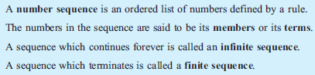

- THE GENERAL TERM OF A NUMBER SEQUENCE
Sequences may be defined in one of the following ways:
- listing all terms (of a finite sequence)
- listing the first few terms and assuming that the pattern represented continues indefinitely
- giving a description in words
- using a formula which represents the general term or nth term
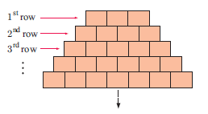
Ex. Express the following sequence in the general term
--------------------------------------------------------------------------------------------------------------------------------------------------------------------------------------------------------------------------------
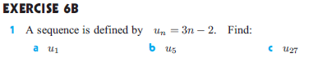

- ARITHMETIC SEQUENCES
Ex:

THE GENERAL TERM FORMULA
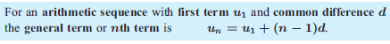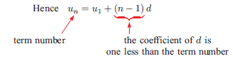
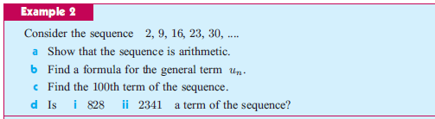

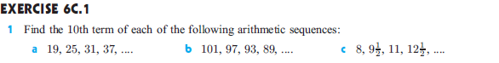

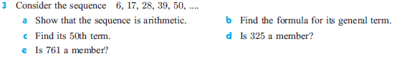

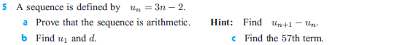
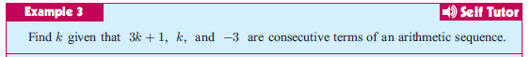

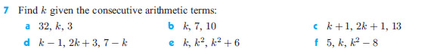

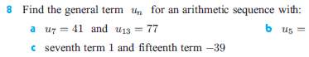

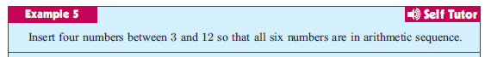

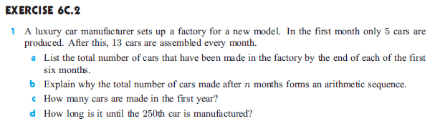

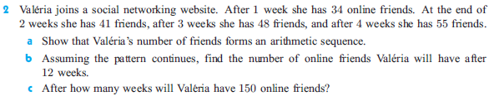

- GEOMETRIC SEQUENCES

For example: 2, 10, 50, 250, .... is a geometric sequence as each term can be obtained by multiplying the previous term by______

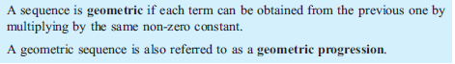

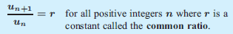
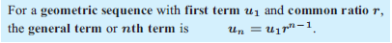
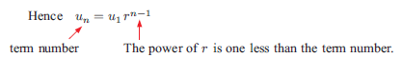
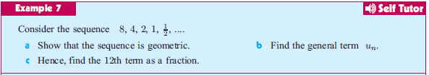
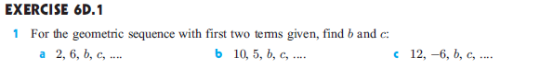

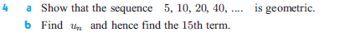

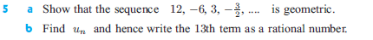

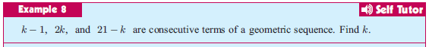

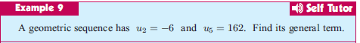

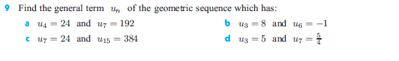

GEOMETRIC SEQUENCE PROBLEMS
Problems of growth and decay involve repeated multiplications by a constant number. We can therefore use geometric sequences to model these situations.
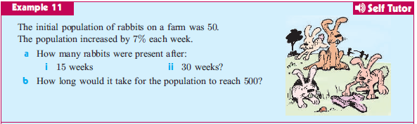

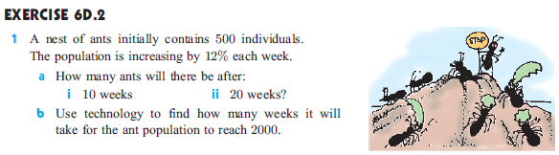

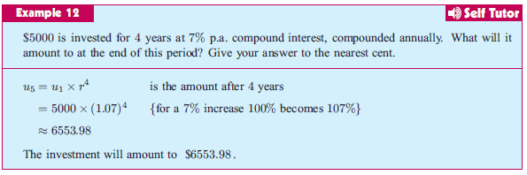

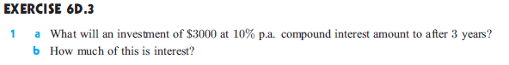

Extra:
- SERIES

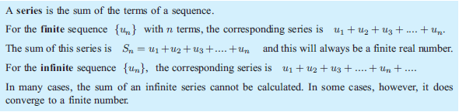

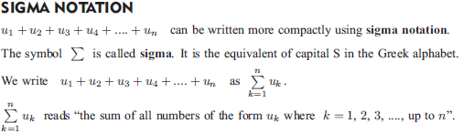

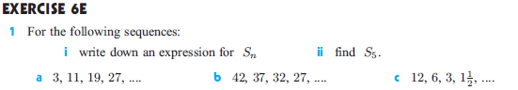

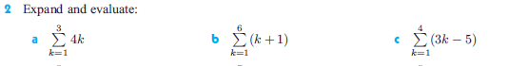

- ARITHMETIC SERIES
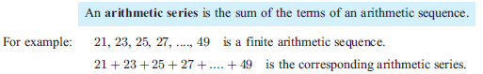

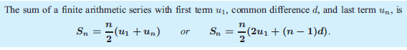

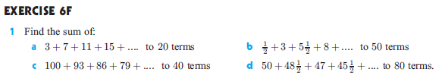

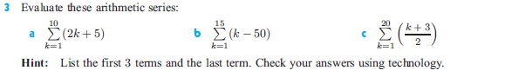

Extra: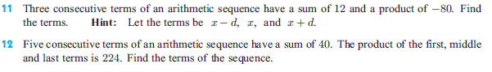
- GEOMETRIC SERIES
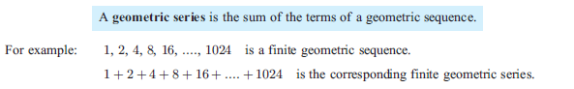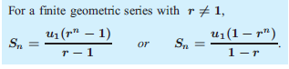
Proof:

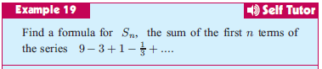

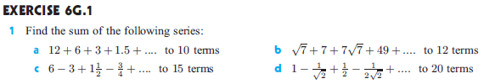

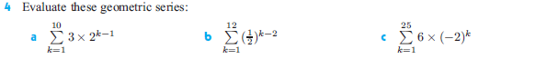

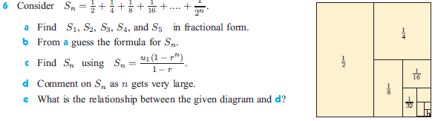

Infinite Geometric Series

An infinite geometric series is the sum of all the terms from an infinite geometric sequence. The symbol for such a sum is $S_{∞}$ .
It is natural to assume that if we keep adding terms “forever” the sum would keep increasing without bound and for many geometric series this is true. We call these divergent series.
ex. $3+6+12+24+…$
However, there are some series that approach a fixed value. For this to happen the terms being added must get smaller and smaller. Therefore, the common ratio must be such that $-1<r<1$ . We call these convergent series.
ex. $1+\frac{1}{2}+\frac{1}{4}+\frac{1}{8}+…$
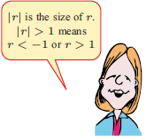
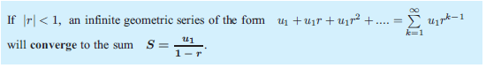
Determine whether each infinite geometric series is convergent or divergent. State the sum, if it exists.
- $1+\frac{1}{5}+\frac{1}{25}+…$ (b) $4-1+\frac{1}{4}-…$ (c) $\frac{1}{8}+\frac{1}{4}+\frac{1}{2}+…$

